Plants Need Minerals
(an introduction to Chemistry)

Age: 8+

Note: The original AMI experiment requires many chemicals, some of them difficult to source. I’ve modified the experiment so you can still have the conversation.

MATERIALS:
- periodic table of elements
- chart #2 (called "The Plant's Menu")
- 6+ little plants (pea plants are a good choice) grown in peat moss (or another non-soil growing medium), that are at the same stage of growth and development (make more than you need so you can choose the 6 healthiest)
- 6 clear jars covered with black paper (roots don't like light)
- Plant nutrient solution: like the one here, which has a variety of minerals that the child can read on the label
- Distilled water (NOT tap, filtered, or reverse osmosis - water must not have any added or naturally-occurring minerals)
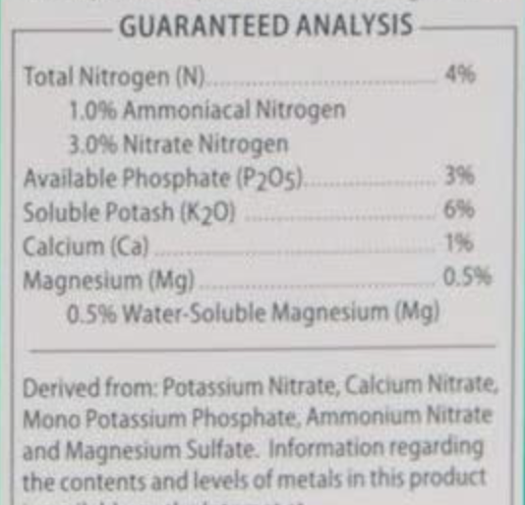

Note: Montessori gives color to the colorless elements that are important to the formation of life.
carbon = black = coal
oxygen = red = fire
water (hydrogen) = blue = oceans
nitrogen = pink = flesh
*the other elements are represented in the color that they have in nature
iron = grey
calcium = white
potassium = white
magnesium = white
chloride = green
sulfur = yellow
phosphorus = pale yellow

Note: This lesson shows chemistry in the service of biology.

PRESENTATION A: Elements
- You know our letters of the alphabet. We have only 26. And yet we have thousands and thousands of words. They are all made out of just those 26 letters. In principle we could have an infinite number of words.
- It’s the same with numbers. Let's think about our numbers: we have 10 digits (1-9 and 0). We can make an infinite number of numbers with these digits.
- Let's think of the Universe. It is made up of many different substances (children can name them if they want) but they are all made out of a limited number of substances that are called elements. They are very simple and pure. We can think of them as the alphabet of creation.
- Do you know how many naturally occurring elements there are on the Earth? Less than 100. When you think of all the substances that make up our world, 100 elements are really few. All of the things that you can see and think of are made up of only 100 elements. They are listed on this table. It's called the Periodic Table of Elements. (Show the table)
- We can find their names... Iron. Each one of these has a symbol. The symbol of iron is "Fe". We get a lot of words from Latin, and in Latin, iron is "ferrum".
- Tin: The symbol is "Sn"
- Gold: The symbol is "Au", comes from Latin "Aurum"
- There are things we are familiar with (calcium, silver), and others that we've probably never heard of, like Californium and Berkelium. The children can explore the table.

- Look at chart #2 with the children.
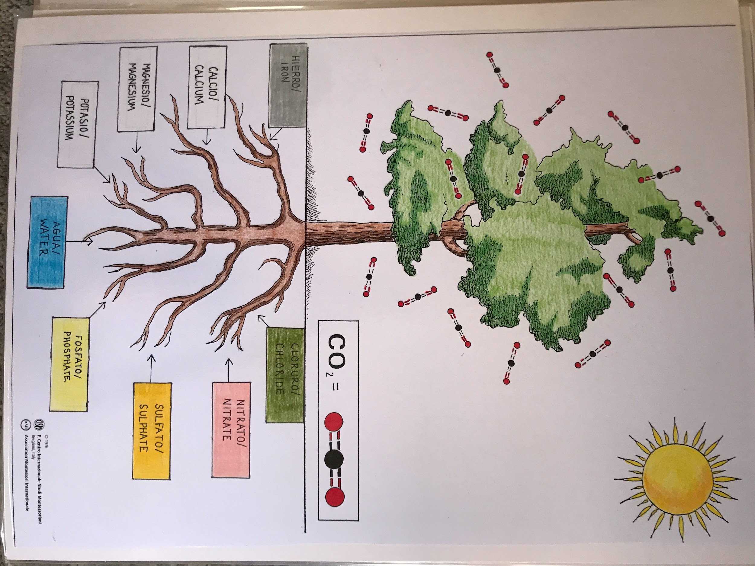

- Today, we're still thinking about the needs of plants. What do we see with this chart? We still see the sun, which represents light and warmth.
- We don't see the cloud around the leaves anymore. What we are seeing represented there is that special gas that we heard about in the Story of Life. It is represented by a little black sphere in the center and a little red sphere on either side. We can read that it says "carbon dioxide". Carbon dioxide is the name of this special gas; it is two parts oxygen and one part carbon. Each time you are seeing that representation, you are seeing one carbon and two oxygens. We can also say "two atoms of oxygen and one atom of carbon". The gas is called carbon dioxide. We hear "carbon" one time, and when we say "di-oxide" we are saying "two oxygens". Show them how it is written on the chart. We are looking at the needs of the plants but in detail.
- The odd thing about this plant is that when we normally look at plants we don't see what's below but now we see; this helps us to think about its needs.
- Let's think of what is in the soil. What is soil? It starts with disintegrated rock (rock dust with minerals). There's also water and also the remains of plants and animals. We have the remains of what was once life in the soil. With all of that, the soil contains many minerals.

Note: If the children have understood elements and understood that elements can combine, we can point out that these elements give us minerals that we can combine. One example is salt. We can look at the labels on mineral water to see what elements are there.

- In the soil we find water (show the blue label). Water is right below the main root because it is very important.
- But there are other minerals: read across, from the left side of the roots to the right side, to name the mineral).
  - iron chloride
  - Calcium nitrate (we know calcium is important for bones; nitrate comes from nitrogen).
  - Magnesium sulphate.
  - Potassium phosphate.
- These are substances that plants like; they constitute the plant's menu.

Notes:
- What we see on the left side of the chart we can find on the table of elements; what we find on the right we will have to modify to what we find on the table. Once they combine, that's where we get the names.
- If we've talked about elements combining to give us new substances just as letters combine to make new words, that is exactly what we're seeing here: two elements combining to make a substance. All of them are called mineral salts.

EXPERIMENT: (same day, after the conversation on elements)
- Plants take all of these in but in order to do that, they have to be dissolved in water - in a solution form. Water is also essential for the plant to take in these mineral salts. That's why it is placed in the central position on our chart.
- Let's do an experiment; we want to see what happens when we give the plant everything. We have to give it in pure water without minerals (DISTILLED - devoid of minerals), so that we can control what the plant is taking in.
- We also want to see what happens if the plant doesn’t get enough nutrients.
- Explain that you are using distilled water, which is pure and has had the minerals removed (if they ask how they were removed, make a note to discuss this later).
- Divide the plants: three go into distilled water, three go into distilled water with plant mineral solution.
- The black paper that goes around the jars and the black paper circles that go on top are already prepared.

Note on the experiment: Use black heavy paper topped with a cross-cut, which is where the plant is going to sit. The leafy part is above the circle and the roots are below. Make a slit so that you insert the plant in the circle. The jar should be filled up sufficiently high with solution so that the roots are in the solution. Observe over time what happens to the little plants.

Results:
- all minerals - remains healthy
- no minerals - remains small, little growth

Conclusion:
- Eventually, all of the plants that have not received minerals will die. If the leaves are not healthy, the plant cannot remain healthy. Since the leaves make food for the plant, and only healthy leaves do that, without the healthy leaves the plant can't grow because it can't eat.

- The children just observe what happens; all that they need to discover is that plants need all those minerals, and they take in those mineral salts dissolved in water. They understand from the chart and experiment that they take all that in through the roots. This is the definition of root (in the classified nomenclature): It takes in mineral salts dissolved in water.

Extension: If your child wants to learn more about the Periodic Table of Elements, you can go to the Introduction to Chemistry and the Periodic Table lesson, found in the Geography 10-11yo section of the Timeline (it’s not necessary to follow age guidelines in science; follow your child’s interest and adapt the difficulty as needed.)

PRESENTATION B: The Nitrogen Cycle
Chart 2a: From death to life (the nitrogen cycle)
*It is a detail of chart 2 and it can come later.

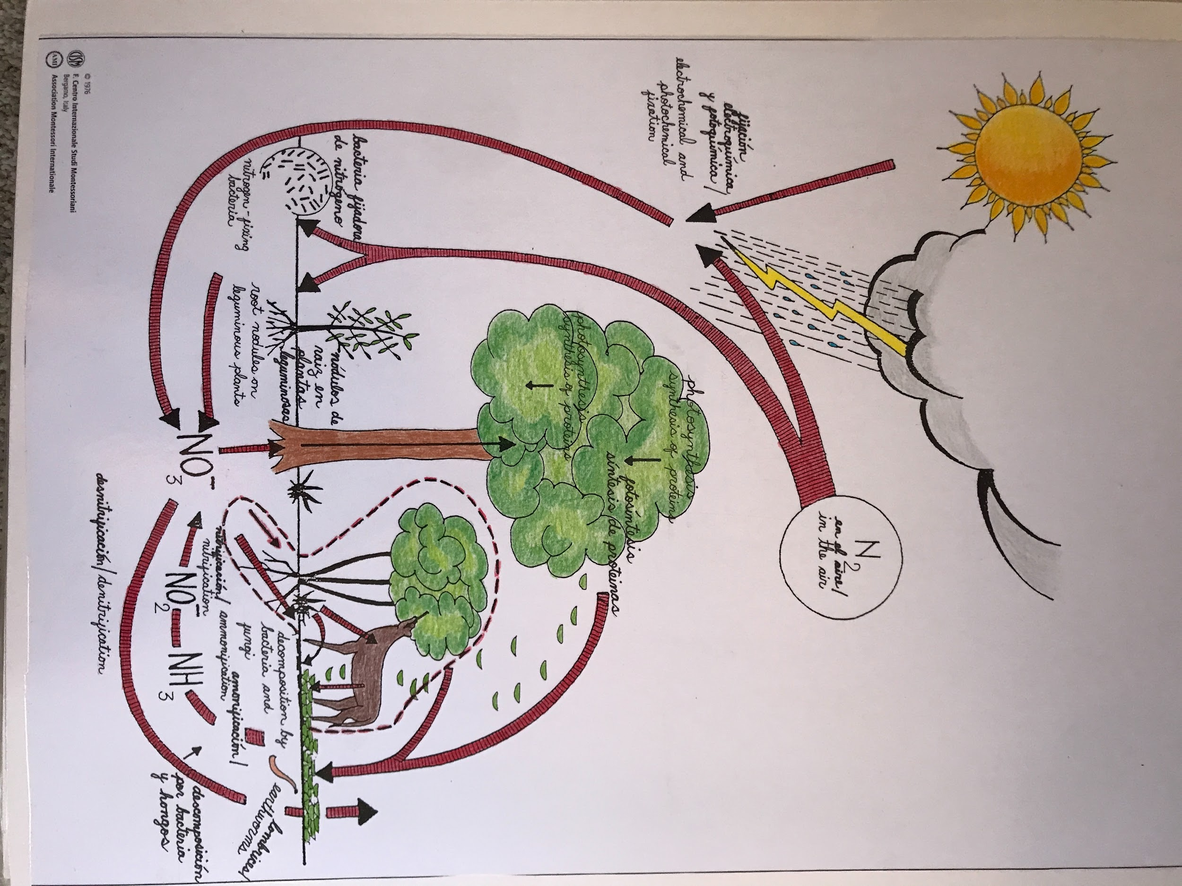
- All forms of life need nitrogen. There's plenty of nitrogen available in our world. Air is actually mostly composed of nitrogen. Roughly, air is made up of 78% nitrogen, 21% oxygen (with other rare gases and 1% water vapor). The major constituent of air is nitrogen. It is available in abundance but plants can't take it in as a gas from the air. For them to take it in, it has to be transformed to a nitrate. Then it is in a form that is accessible to plants.
- The chart is showing us the process that is involved in the passage from nitrogen to nitrate. It's a cycle because once we have the nitrate, it can be transformed back into nitrogen and released into the air. This is how we get a full cycle. (Show chart #2, where it says "calcium nitrate").
- On chart 2a we see nitrogen in the air and nitrate underground. There are all the different ways of converting from the gas to the salt, and vice versa. All living bodies have nitrogen, so when living things decompose they are converted into nitrate. We see a conversion from life to death, which makes nitrogen available, which makes life again.

Note: This is why we call this chart "From death to life". What is important is not just looking at it from a plant's perspective, but giving the general idea that all that dies later contributes to future life. Everything is recycled and everything is reused in nature. There is no such thing as waste in nature; what is waste for one thing is food for something else.

